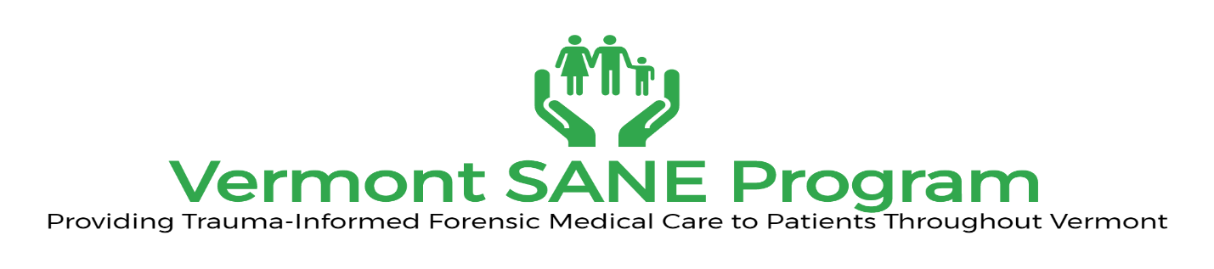
SANE Training at the University of Vermont Simulation Lab

The purpose of this education is to provide new and updated information on the care of patients who have experienced sexual violence. The education day will include lectures, case review and case simulation with live gynecological teaching assistants

This Training is free to Vermont SANEs
Cost for out of state SANEs or non-SANEs will be $40

Date: Saturday February 3rd
Time: 8am-4 pm
Location: UVM Simulation Lab

Register

The purpose of this education is to provide new and updated information on the care of patients who have experienced sexual violence. The education day will include lectures, case review and case simulation with live gynecological teaching assistants

This Training is free to Vermont SANEs
Cost for out of state SANEs or non-SANEs will be $40

Continuing Education Credits from VSNA: CEUs will be issued for 7 CEUs.
The Vermont SANE Program is an approved provider of continuing nursing education by Vermont Nurses’ Association’s Committee on Education, an accredited approver by the American Nurses Credentialing Center’s Commission on Accreditation.

For Questions: Raenetta Liberty, RN, SANE-A
Raenetta@vtnetwork.org
802.223.1302 X 111
Deadline for registration is January 29, 2018

